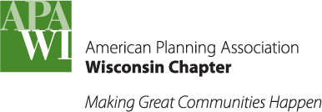
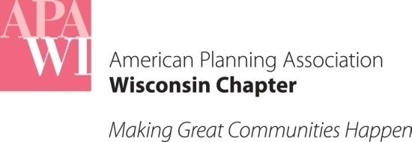
For questions or comments, please contact:
Brian W. Ohm, JD
Dept. of Planning + Landscape Architecture
UW-Madison
925 Bascom Mall
Madison, WI 53706
bwohm@wisc.edu

August Case Law Update
August 31, 2022

A summary of court opinions decided during the month of August affecting planning in Wisconsin

Wisconsin Supreme Court Opinions

[No planning-related cases to report.]

Wisconsin Court of Appeals Opinions

No Conflict of Interest by Village Board Trustee in Rezoning

Miller v. Zoning Board of Appeals of the Village of Lyndon Station involved the appeal of a circuit court judgment finding an error in the Village Board’s rezoning proceedings. The Village of Lyndon Station rezoned a 1.87-acre vacant lot from residential to commercial. The rezoning followed the standard process under state law requiring a recommendation from the plan commission and ultimate adoption by the Village Board. The mother of one of the owners of the lot was a trustee on the Village Board and was chair of the plan commission. The mother also lived with the lot owners. Some Village residents questioned whether the mother had a conflict of interest that would prevent her from voting on the application. The Village attorney opined that the mother did not have a conflict of interest under Wis. Stat. § 19.59 governing conflicts of interest for local government officials.

Following the Village Board’s decision to approve the rezoning, one resident (Miller) appealed the decision to the Village Zoning Board of Appeals (ZBA). The ZBA voted to uphold the Village Board’s decision. Miller then sued the Village and the lot owner in circuit court alleging it was improper for the mother to have participated in the Village Board’s proceedings. The circuit court determined that the mother’s participation in the proceedings violated Miller’s due process right to a fair and impartial hearing. The lot owner (not the Village) appealed the circuit court decision.

On appeal, the parties agreed that the mother did not violate state ethics statutes, Wis. Stat. §§ 19.41-19.59. The Court of Appeals noted that a rezoning is a proposal to modify the Village’s zoning ordinance and Wis. Stat. § 19.59(1)(d) expressly states that the statutes barring local official from taking official actions in which the official or an immediate family member has a substantial financial interest do not “prohibit a local public official from taking official action with respect to any proposal to modify a county or municipal ordinance.”

Instead, Miller’s due process argument relied exclusively on the common law notions of fair play which may require a decisionmaker’s recusal even in the absence of any explicit statutory command. The Court of Appeals noted the distinction the courts make between quasi-judicial and quasi-legislative actions by local governments. The Court of Appeals decision includes an extended discussion that a rezoning is a legislative act. Given the Court’s historic deference to discretionary legislative decisions, the Court of Appeals did not find support for Miller’s argument that common law due process required the members of the Village Board to be impartial. The Court of Appeals reversed the circuit court’s decision and reinstated the rezoning of the lot.

The case is recommended for publication in the official reports.

U.S. Court of Appeals for the 7th Circuit Opinions

State May Not Tax Tribal Lands

Lac Court Oreilles Band of Lake Superior Chippewa Indians of Wisconsin v. Evers, concerned the taxation of tribal lands which, though owned today by Ojibwe tribal members, were sold by past tribal owners to non-Indians before coming back into tribal ownership. The State of Wisconsin assessed property taxes on the lands arguing that the one-time act of alienating reservation property to a non-Indian surrenders the parcel’s tax immunity for all time. The Federal Court of Appeals for the Seventh Circuit disagreed and held the State did not have the authority to tax reacquired reservation lands.

The Court’s opinion includes a lengthy discussion of the complicated legal history of tribal land in the United States that is worth reading.

First Amendment Challenge to the Mask Mandate Fails

Helbachs Café LLC v. City of Madison, involved a failure to comply with COVID-19 mask mandate. After the public health department for the City of Madison and Dane County issued a COVID-19 mask mandate, an owner of Helbachs Café posted a sign: “Mask Free Zone. Please remove mask before entering” and then took it down about 30 minutes later. Over the next few days, Madison’s public health officials cited Helbachs several times for violating its COVID-19 orders. Helbachs sued the City of Madison and Dane County under 42 U.S.C. § 1983 claiming that the defendants retaliated against Helbachs in violation of the First Amendment for posting its anti-mask sign. The Court of Appeals for the Seventh Circuit affirmed the district court’s judgement in favor of the defendants finding that Helbachs failed to present evidence that the defendants’ actions were part of a larger pattern or practice of retaliation.

Previous updates are available at: wisconsin.planning.org/policy-and-advocacy/law-updates/case-law-updates/

