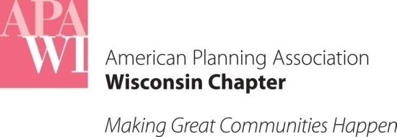
For questions or comments, please contact:
Brian W. Ohm, JD
Dept. of Planning + Landscape Architecture
UW-Madison/Extension
925 Bascom Mall
Madison, WI 53706
bwohm@wisc.edu

September Case Law Update
September 30, 2018

A summary of Wisconsin court opinions decided during the month of September
related to planning

Previous Case Law Updates are available at: wisconsin.planning.org/policy-and-advocacy/law-updates/case-law-updates/

Wisconsin Supreme Court Opinions

[No planning-related cases to report.]

Wisconsin Court of Appeals Opinions

City Ordinance Prohibiting Trains From Obstructing Crossings Preempted by Federal Law

City of Weyauwega v. Wisconsin Central Ltd., involved a challenge by the Wisconsin Central railroad to numerous citations issued by the City of Weyauwega for violating a City ordinance that prohibited trains from obstructing travel at road crossings for more than 10 minutes. The City argued the ordinance was necessitated by public safety concerns. The City’s police, fire and emergency services were housed south of the railroad tracks. The response time for these services increase from about 1 minute to 12 – 15 minutes when trains obstruct the crossings. Wisconsin Central argued that the 1970 Federal Railroad Safety Act (FRSA) preempted the City’s ordinance.

FRSA expressly preempts state law in areas covered by the FSRA. The Court concluded that the preemption also applies to local regulations. FSRA also includes several “saving clauses” that allows states to regulate railroads. One of the clauses allows State regulations necessary to eliminate or reduce a local safety hazard. The Court of Appeals was not persuaded by the City’s argument that the ordinance was needed for public safety because the Court focused on the effect of the ordinance. The Court noted the City’s ordinance effected the operation and movement of trains as crossings, an area of regulation that was covered in FSRA. As a result, the Court of Appeals decided the City’s ordinance was preempted by FSRA. The Court also noted that perhaps the federal government could develop national uniform standards that addressed the City’s concerns.

The case is recommended for publication in the official reports.

U.S. Court of Appeals for the 7th Circuit Opinions

[No planning-related cases to report.]

